Chang’an University 2023－2024 The 2nd semester （ B ）
Course | Hydraulic and Pneumatic Transmission |  |  | Date |  | / / |  | 18 questions
Name |  | School |  |  | Class |  | ID
I Fill in the blanks. (10 points, 1 point for each blank)
- The three fundamental equations of fluid motion and fluid dynamics are the ______, ______, and ______ equations.
- The maximum pressure of a pressure-limiting variable vane pump is determined by ______.
- The loss of flow during the energy conversion process of a hydraulic pump, caused by internal leakage, cavitation, and compression of the oil under high pressure, is called ______.
- When a hydraulic cylinder is driven by hydraulic oil for reciprocating motion, the system pressure is mainly determined by ______. When the effective working area of the piston in the hydraulic cylinder is constant, its speed depends on ______.
- The main issues with external gear pumps include ______, ______, and ______.
II Short answer question items. (30 points, 5 points for each)
- Describe the causes of cavitation.

- Explain the basic conditions for a positive displacement hydraulic pump.

- What is the displacement (delivery) of a hydraulic pump? What are the theoretical and actual flow rates of a hydraulic pump?

- Explain the differences between a pilot-operated relief valve and a pilot-operated pressure reducing valve.

- Describe the working principle and types of throttle speed control circuits.

- Explain the main functions of an accumulator.
第 1 页(共 4 页)
III Calculations. (25 points)
1. A water storage device is shown in the figure. The reservoir is large enough that when the valve is closed, the pressure gauge reads 2.8 atmospheres (relative to atmospheric pressure). When the valve is fully open and water flows out of the pipe, the pressure gauge reads 0.6 atmospheres. Calculate the volumetric flow rate through the outlet when the pipe diameter is d = 12 cm. (Neglect flow losses and assume one atmosphere is 1×10⁵ Pa and gravitational acceleration g is 10 m/s²). (10 points)
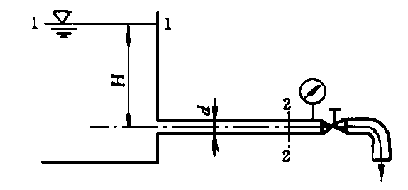

2. In the hydraulic system shown, the piston areas of the hydraulic cylinders are A₁ = A₂ = A₃ = 20×10⁻⁴m², and the rod areas of the three cylinders are A = 10×10⁻⁴m². The loads are F₁ = 4000 N, F₂ = 6000 N, F₃ = 8000 N, and the hydraulic pump flow rate is Q = 50 L/min. The relief valve is set at a pressure p_{y}. Calculate and analyze the following: (15 points)
(1) In diagram (a), when p_{y} = 2.5 MPa, which of the three hydraulic cylinders can operate? (5 points)
(2) In diagram (a), what is the operating sequence of the three hydraulic cylinders when p_{y} = 5 MPa? (5 points)
(3) When the relief valve functions as a safety valve and is in a closed state, analyze and calculate the movement states and speeds of the hydraulic cylinders in diagrams (a) and (b). (5 points)
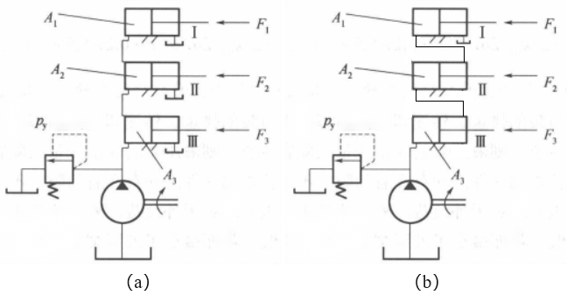
第 2 页(共 4 页)

IV Diagramming question. (20 points)
Please write the name of basic hydraulic circuits (6 points) and hydraulic components (9 points).

(1) | (2)
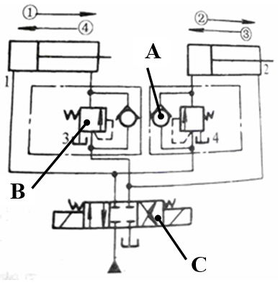 | 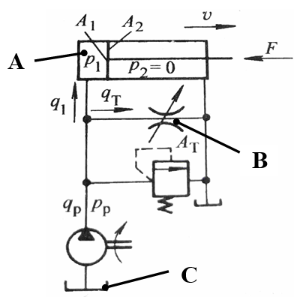

Hydraulic basic circuit |  |  | Hydraulic basic circuit
Component A |  |  | Component A
Component B |  |  | Component B
Component C |  |  | Component C

（3） （4）
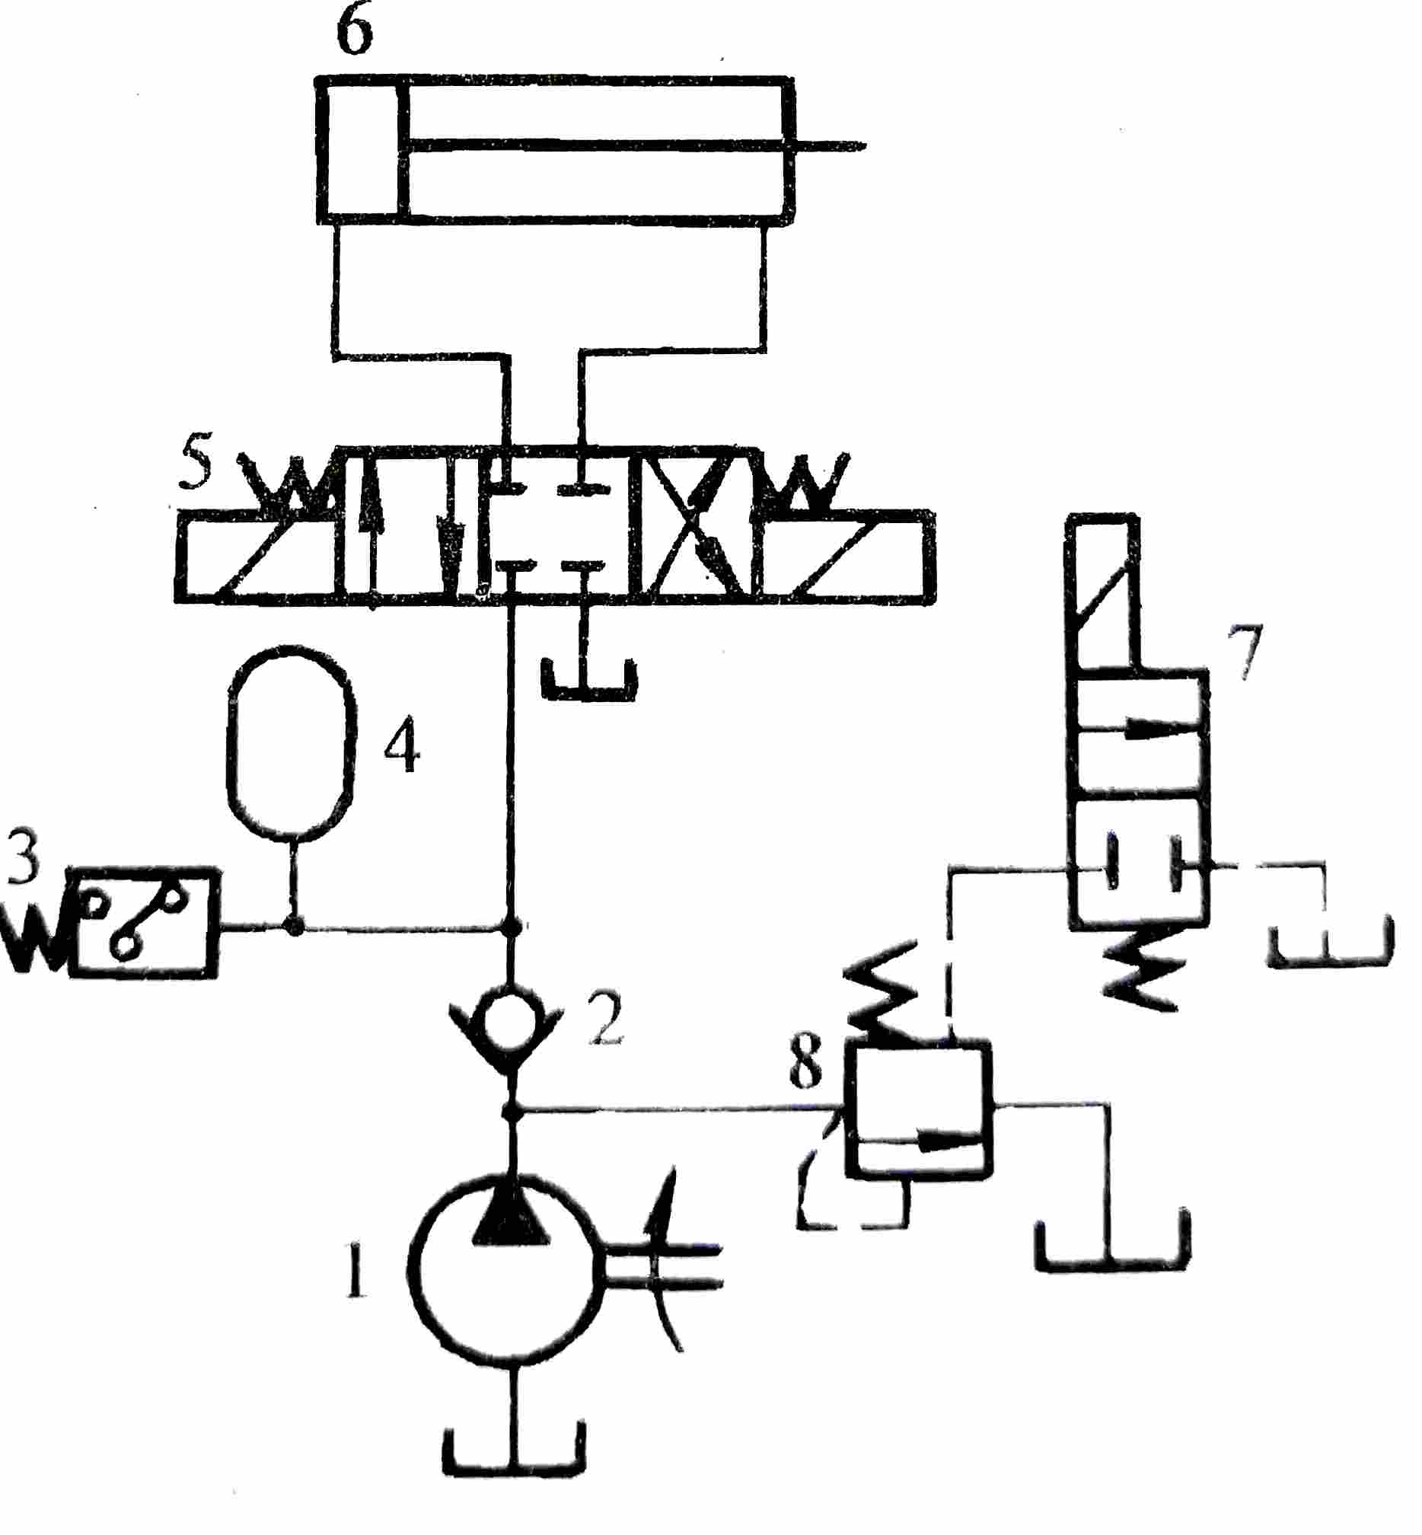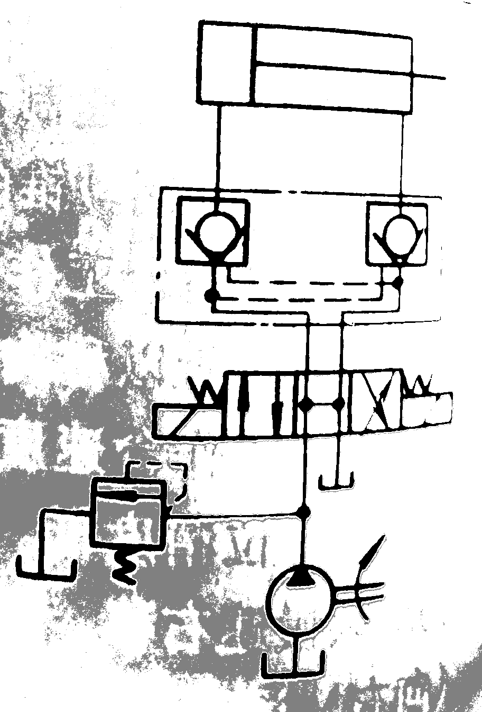
A
B
C
A
B
C
Hydraulic basic circuit |  |  | Hydraulic basic circuit
Component A |  |  | Component A
Component B |  |  | Component B
Component C |  |  | Component C

第 3 页(共 4 页)
V Analysis. (15 Points)
Based on the given solenoid action sequence table and the hydraulic system diagram, answer the following questions. (15 points)
(1) When the system performs the rapid feed, what is the flow path of the oil in the circuit? What is the name of the basic circuit used? (5 points)
(2) When the system performs the working feed, what is the flow path of the oil in the circuit? What is the name of the basic circuit used? (5 points)
(3) When the system performs the rapid retraction, what is the flow path of the oil in the circuit? (5 points)

Solenoid Working States
Solenoid Working States | 1YA | 2YA | 3YA
Rapid feed | ＋ | － | ＋
Working feed | ＋ | － | －
Hold | ＋ | － | －
Quick retract | － | ＋ | －
Stop | － | － | －
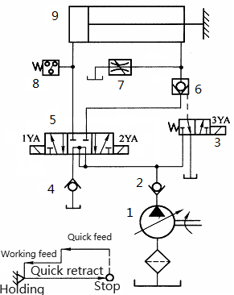

第 4 页(共 4 页)

